Prepared By: Keshab Rai
Project: Covid-19 Analytics (AWS)-End to End
Date: May 31, 2026
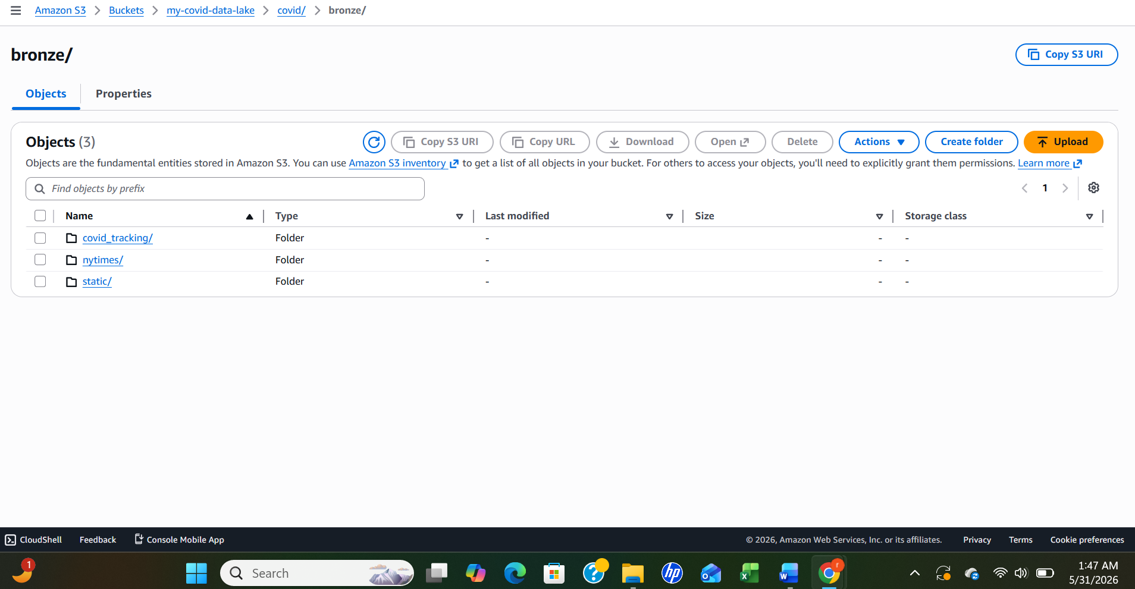

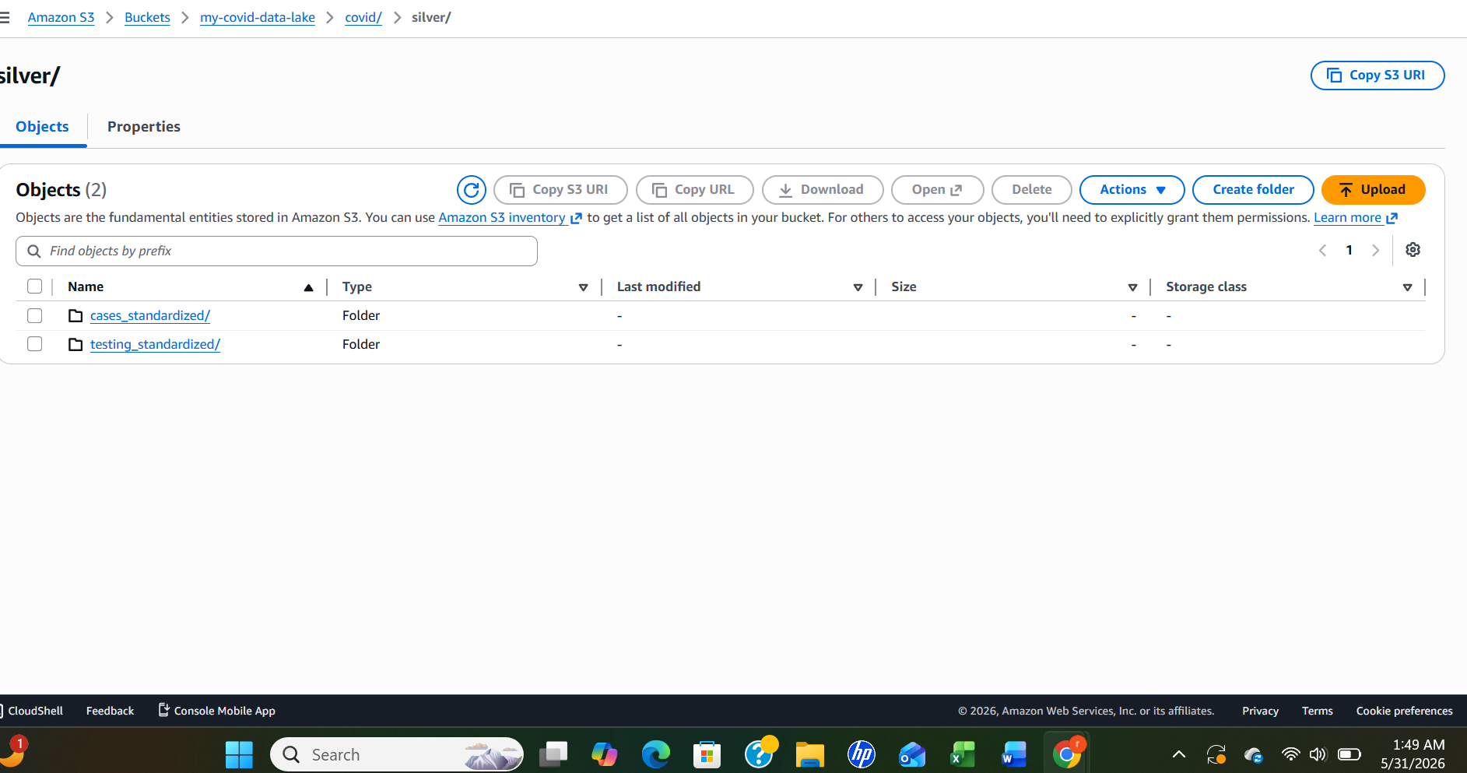

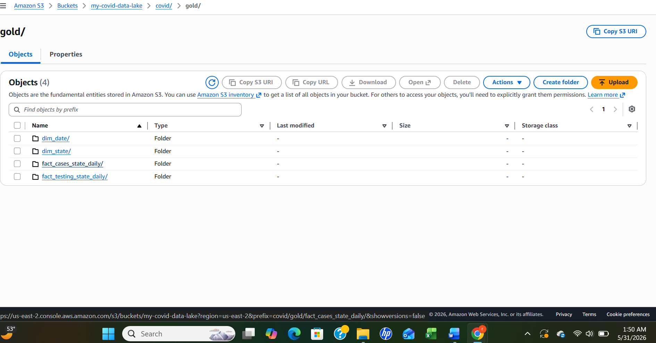

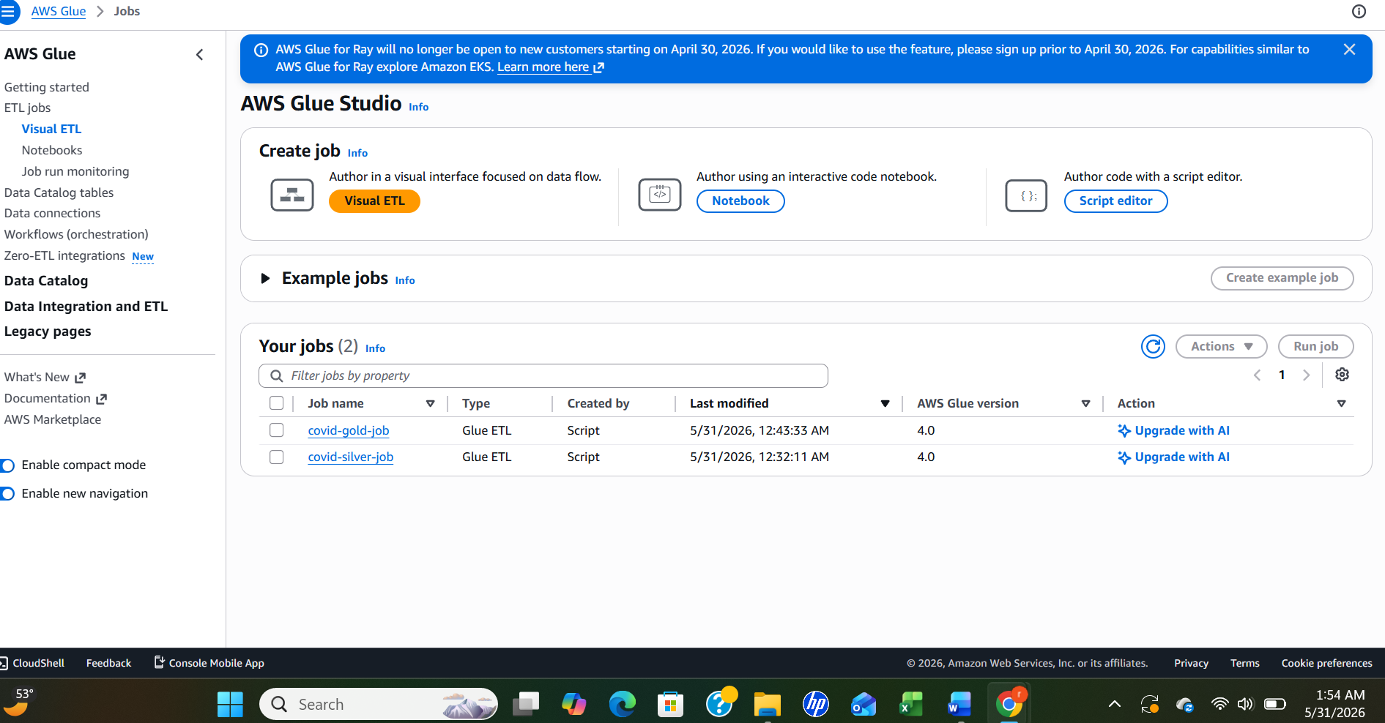

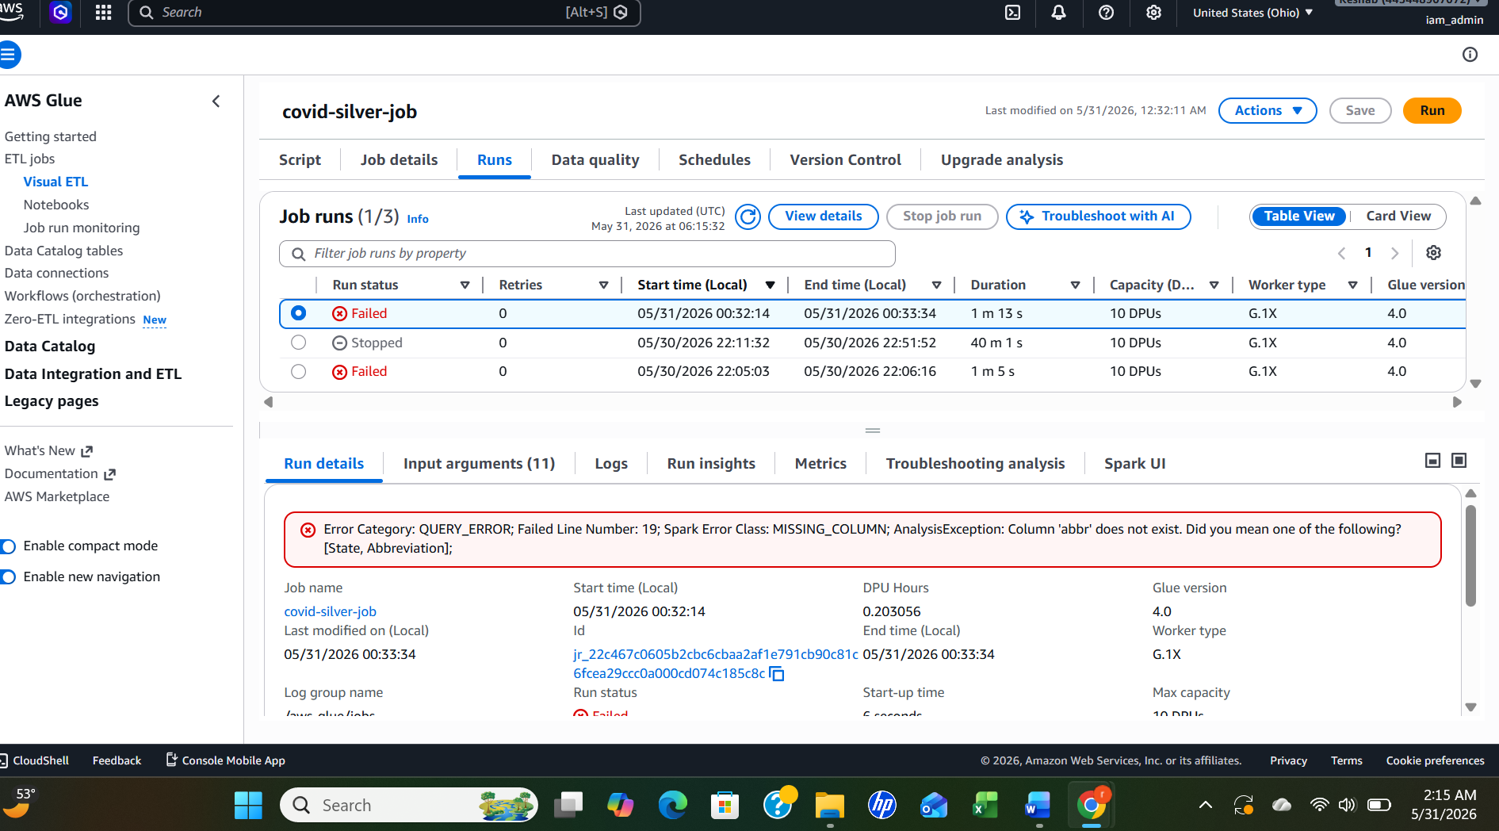

# ---- SILVER BUILD (PySpark) ----

from pyspark.sql import SparkSession, functions as F
BUCKET = "my-covid-data-lake"
BRONZE = f"s3://{BUCKET}/covid/bronze"
SILVER = f"s3://{BUCKET}/covid/silver"

spark = SparkSession.builder.appName("covid-minimal-silver").getOrCreate()

# Helpers
upper_trim = lambda c: F.upper(F.trim(F.col(c)))
to_date = lambda c: F.to_date(F.col(c).cast("string"))
# --- Lookups ---
states = (spark.read.option("header", True).csv(f"{BRONZE}/static/states_abv.csv")
.select(upper_trim("abbr").alias("state_code"), F.initcap("name").alias("state_name")))

# --- Cases (NYT state file: date,state,cases,deaths or JHU state-level variant) ---
cases_raw = spark.read.option("header", True).csv(f"{BRONZE}/nytimes/us_states.csv")

cases_std = (cases_raw
# Handle date formats like "2020-05-01" or yyyymmdd; adjust if needed
.withColumn("full_date", F.to_date("date"))
# If the file stores state NAME, map to code; if it already stores code, this join still works
.withColumn("state_name_raw", F.initcap(F.col("state")))
.join(states, states.state_name == F.col("state_name_raw"), "left")
.withColumn("cases_cum", F.col("cases").cast("long"))
.withColumn("deaths_cum", F.col("deaths").cast("long"))
.withColumn("year", F.year("full_date"))
.withColumn("month", F.month("full_date"))
.withColumn("day", F.dayofmonth("full_date"))
.select("full_date", "state_code", "state_name", "cases_cum", "deaths_cum", "year", "month", "day")
.dropna(subset=["full_date", "state_code"])
)

(cases_std.write.mode("overwrite")
.partitionBy("state_code", "year", "month", "day")
.parquet(f"{SILVER}/cases_standardized"))
# --- Testing (COVID Tracking: date(int yyyymmdd), state(code), positive, negative, totalTestResults) ---
tests_raw = spark.read.option("header", True).csv(f"{BRONZE}/covid_tracking/states_daily.csv")

tests_std = (tests_raw
.withColumn("full_date", F.to_date(F.col("date").cast("string"), "yyyyMMdd"))
.withColumn("state_code", upper_trim("state"))
.join(states.select("state_code", "state_name"), "state_code", "left")
.withColumn("tests_total_cum", F.col("totalTestResults").cast("long"))
.withColumn("tests_pos_cum", F.col("positive").cast("long"))
.withColumn("tests_neg_cum", F.col("negative").cast("long"))
.withColumn("year", F.year("full_date"))
.withColumn("month", F.month("full_date"))
.withColumn("day", F.dayofmonth("full_date"))
.select("full_date", "state_code", "state_name", "tests_total_cum", "tests_pos_cum", "tests_neg_cum", "year", "month", "day")
.dropna(subset=["full_date", "state_code"])
)

(tests_std.write.mode("overwrite")
.partitionBy("state_code", "year", "month", "day")
.parquet(f"{SILVER}/testing_standardized"))

print("Silver complete.")

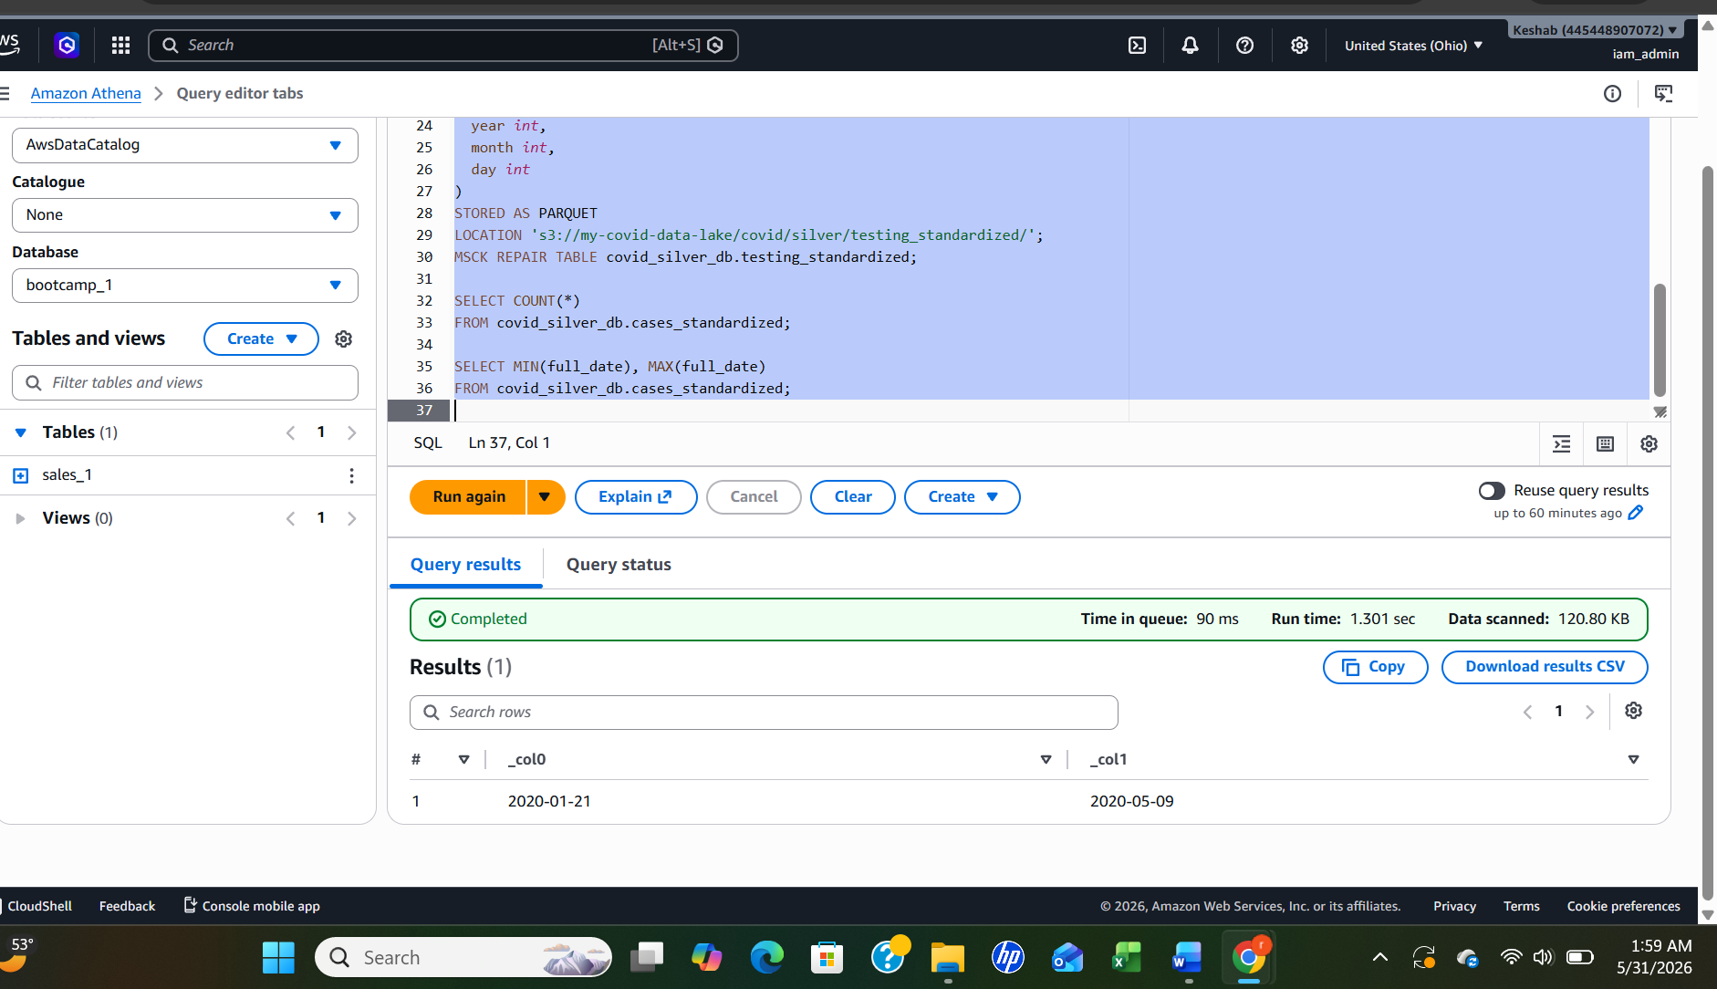
-- ---- ATHENA (SILVER) ----
CREATE EXTERNAL TABLE IF NOT EXISTS covid_silver_db.cases_standardized (
full_date date,
state_code string,
state_name string,
cases_cum bigint,
deaths_cum bigint,
year int,
month int,
day int
)
STORED AS PARQUET
LOCATION 's3://my-covid-data-lake/covid/silver/cases_standardized/';

MSCK REPAIR TABLE covid_silver_db.cases_standardized;

CREATE EXTERNAL TABLE IF NOT EXISTS covid_silver_db.testing_standardized (
full_date date,
state_code string,
state_name string,
tests_total_cum bigint,
tests_pos_cum bigint,
tests_neg_cum bigint,
year int,
month int,
day int
)
STORED AS PARQUET
LOCATION 's3://my-covid-data-lake/covid/silver/testing_standardized/';
MSCK REPAIR TABLE covid_silver_db.testing_standardized;

SELECT COUNT(*)
FROM covid_silver_db.cases_standardized;

SELECT MIN(full_date), MAX(full_date)
FROM covid_silver_db.cases_standardized;

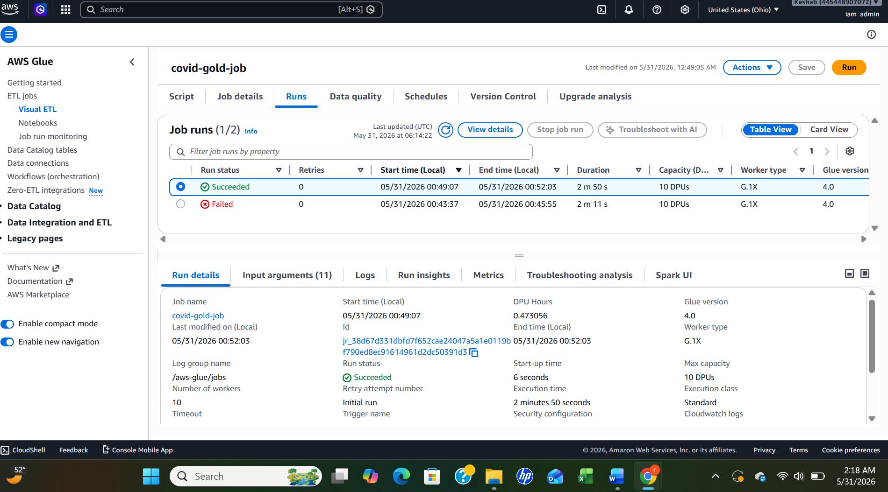

# ---- GOLD BUILD (PySpark) ----
from pyspark.sql import SparkSession, functions as F, window as W

BUCKET = "my-covid-data-lake"
SILVER = f"s3://{BUCKET}/covid/silver"
GOLD = f"s3://{BUCKET}/covid/gold"

spark = SparkSession.builder.appName("covid-minimal-gold").getOrCreate()

cases = spark.read.parquet(f"{SILVER}/cases_standardized")
tests = spark.read.parquet(f"{SILVER}/testing_standardized")

# dim_date
all_dates = (cases.select("full_date").union(tests.select("full_date")).dropDuplicates())
dim_date = (all_dates
.withColumn("date_id", F.date_format("full_date", "yyyyMMdd").cast("int"))
.withColumn("year", F.year("full_date"))
.withColumn("month", F.month("full_date"))
.withColumn("day", F.dayofmonth("full_date"))
.withColumn("dow", F.date_format("full_date", "u").cast("int"))
.withColumn("is_weekend", F.col("dow").isin([6,7]))
)
dim_date.write.mode("overwrite").parquet(f"{GOLD}/dim_date")

# dim_state
dim_state = cases.select("state_code", "state_name").dropDuplicates()
dim_state.write.mode("overwrite").parquet(f"{GOLD}/dim_state")

# fact_cases_state_daily
w = W.Window.partitionBy("state_code").orderBy("full_date")
fact_cases = (cases
.withColumn("date_id", F.date_format("full_date", "yyyyMMdd").cast("int"))
.withColumn("new_cases", F.greatest(F.col("cases_cum") - F.lag("cases_cum").over(w), F.lit(0)))
.withColumn("new_deaths", F.greatest(F.col("deaths_cum") - F.lag("deaths_cum").over(w), F.lit(0)))
.select("date_id", "state_code", "cases_cum", "deaths_cum", "new_cases", "new_deaths")
)
fact_cases.write.mode("overwrite").partitionBy("state_code").parquet(f"{GOLD}/fact_cases_state_daily")

# fact_testing_state_daily
w2 = W.Window.partitionBy("state_code").orderBy("full_date")
fact_tests = (tests
.withColumn("date_id", F.date_format("full_date", "yyyyMMdd").cast("int"))
.withColumn("new_tests", F.greatest(F.col("tests_total_cum") - F.lag("tests_total_cum").over(w2), F.lit(0)))
.withColumn("positivity_rate", F.when(F.col("tests_total_cum") > 0,
(F.col("tests_pos_cum") / F.col("tests_total_cum")).cast("double")))
.select("date_id", "state_code", "tests_total_cum", "tests_pos_cum", "tests_neg_cum", "new_tests", "positivity_rate")
)
fact_tests.write.mode("overwrite").partitionBy("state_code").parquet(f"{GOLD}/fact_testing_state_daily")

print("Gold complete.")

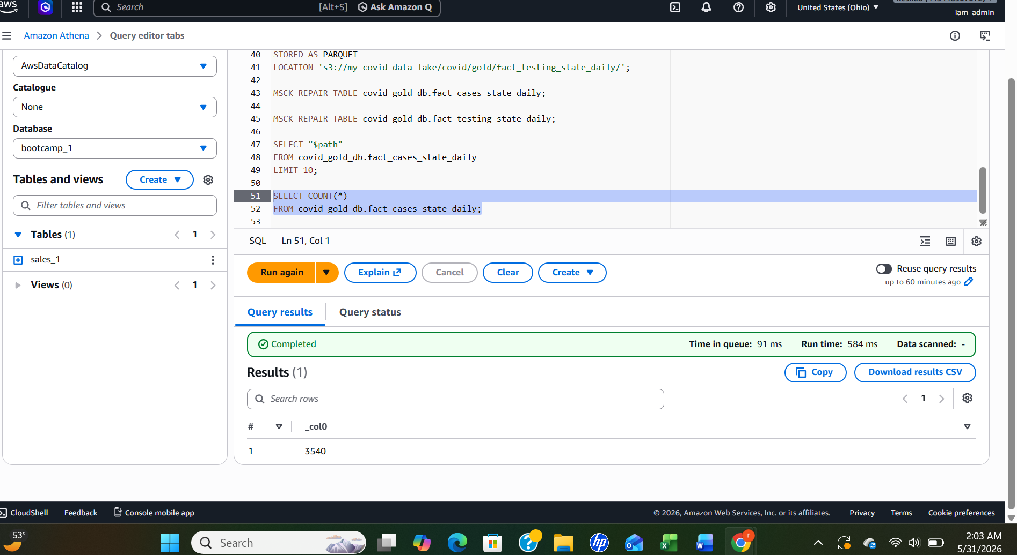
-- ---- ATHENA (GOLD) ----
CREATE DATABASE IF NOT EXISTS covid_gold_db;
CREATE EXTERNAL TABLE IF NOT EXISTS covid_gold_db.dim_date (
date_id int,
full_date date,
year int,
month int,
day int,
dow int,
is_weekend boolean
)
STORED AS PARQUET
LOCATION 's3://my-covid-data-lake/covid/gold/dim_date/';
CREATE EXTERNAL TABLE IF NOT EXISTS covid_gold_db.dim_state (
state_code string,
state_name string
)
STORED AS PARQUET
LOCATION 's3://my-covid-data-lake/covid/gold/dim_state/';

CREATE EXTERNAL TABLE IF NOT EXISTS covid_gold_db.fact_cases_state_daily (
date_id int,
cases_cum bigint,
deaths_cum bigint,
new_cases int,
new_deaths int
)
PARTITIONED BY (state_code string)
STORED AS PARQUET
LOCATION 's3://my-covid-data-lake/covid/gold/fact_cases_state_daily/';

CREATE EXTERNAL TABLE IF NOT EXISTS covid_gold_db.fact_testing_state_daily (
date_id int,
tests_total_cum bigint,
tests_pos_cum bigint,
tests_neg_cum bigint,
new_tests int,
positivity_rate double
)
PARTITIONED BY (state_code string)
STORED AS PARQUET
LOCATION 's3://my-covid-data-lake/covid/gold/fact_testing_state_daily/';

MSCK REPAIR TABLE covid_gold_db.fact_cases_state_daily;

MSCK REPAIR TABLE covid_gold_db.fact_testing_state_daily;

SELECT "$path"
FROM covid_gold_db.fact_cases_state_daily
LIMIT 10;

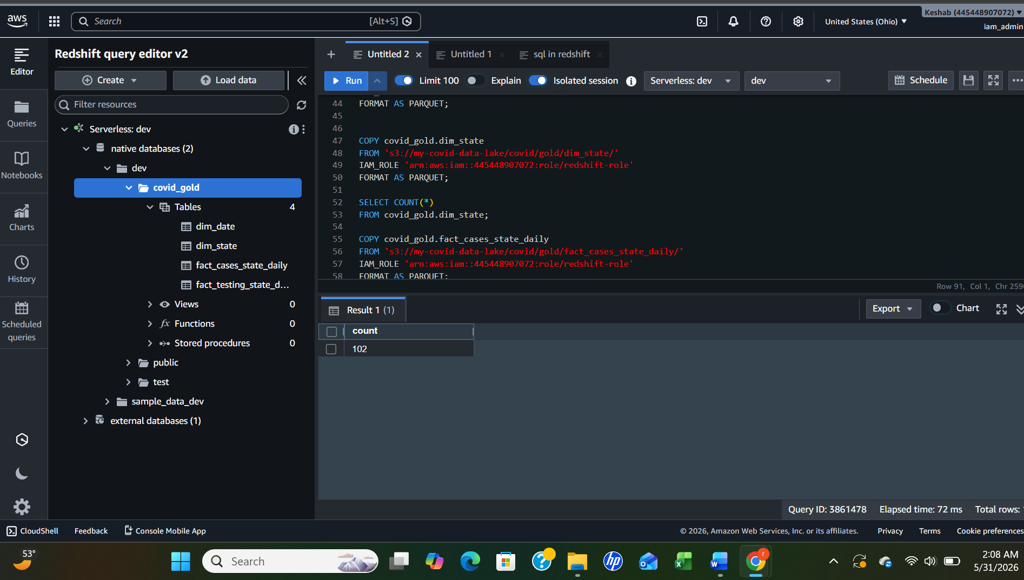
CREATE SCHEMA IF NOT EXISTS covid_gold;
CREATE TABLE IF NOT EXISTS covid_gold.dim_date (
date_id int PRIMARY KEY,
full_date date,
year smallint,
month smallint,
day smallint,
dow smallint,
is_weekend boolean
)
SORTKEY(date_id);
CREATE TABLE IF NOT EXISTS covid_gold.dim_state (
state_code varchar(2) PRIMARY KEY,
state_name varchar(64)
)
DISTSTYLE ALL;

CREATE TABLE IF NOT EXISTS covid_gold.fact_cases_state_daily (
date_id int NOT NULL,
state_code varchar(2) NOT NULL,
cases_cum bigint,
deaths_cum bigint,
new_cases int,
new_deaths int
)
DISTKEY(state_code)
SORTKEY(date_id, state_code);

CREATE TABLE IF NOT EXISTS covid_gold.fact_testing_state_daily (
date_id int NOT NULL,
state_code varchar(2) NOT NULL,
tests_total_cum bigint,
tests_pos_cum bigint,
tests_neg_cum bigint,
new_tests int,
positivity_rate double precision
)
DISTKEY(state_code)
SORTKEY(date_id, state_code);

COPY covid_gold.dim_date
FROM 's3://my-covid-data-lake/covid/gold/dim_date/'
IAM_ROLE 'arn:aws:iam::445448907072:role/redshift-role'
FORMAT AS PARQUET;

COPY covid_gold.dim_state
FROM 's3://my-covid-data-lake/covid/gold/dim_state/'
IAM_ROLE 'arn:aws:iam::445448907072:role/redshift-role'
FORMAT AS PARQUET;

SELECT COUNT(*)
FROM covid_gold.dim_state;

COPY covid_gold.fact_cases_state_daily
FROM 's3://my-covid-data-lake/covid/gold/fact_cases_state_daily/'
IAM_ROLE 'arn:aws:iam::445448907072:role/redshift-role'
FORMAT AS PARQUET;

COPY covid_gold.fact_testing_state_daily
FROM 's3://my-covid-data-lake/covid/gold/fact_testing_state_daily/'
IAM_ROLE 'arn:aws:iam::445448907072:role/redshift-role'
FORMAT AS PARQUET;

SELECT s.state_name, f.new_cases
FROM covid_gold.fact_cases_state_daily f
JOIN covid_gold.dim_state s ON s.state_code = f.state_code
WHERE f.date_id = 20200515
ORDER BY f.new_cases DESC
LIMIT 5;

SELECT d.full_date,
(t.tests_pos_cum::double precision / NULLIF(t.tests_total_cum, 0)) AS positivity_rate
FROM covid_gold.fact_testing_state_daily t
JOIN covid_gold.dim_date d ON d.date_id = t.date_id
WHERE t.state_code = 'NY'
ORDER BY d.full_date;

SELECT d.full_date,
c.new_cases,
t.new_tests,
(t.tests_pos_cum::double precision / NULLIF(t.tests_total_cum, 0)) AS positivity_rate
FROM covid_gold.fact_cases_state_daily c
JOIN covid_gold.fact_testing_state_daily t
ON t.date_id = c.date_id AND t.state_code = c.state_code
JOIN covid_gold.dim_date d ON d.date_id = c.date_id
WHERE c.state_code = 'CA'
ORDER BY d.full_date;

